**Supplementary Information**

Figure S1. Boston City Boundary with stations chosen in various density blocks (light yellow is low population density, light orange to orange is medium to medium-high density, and red represents high density).

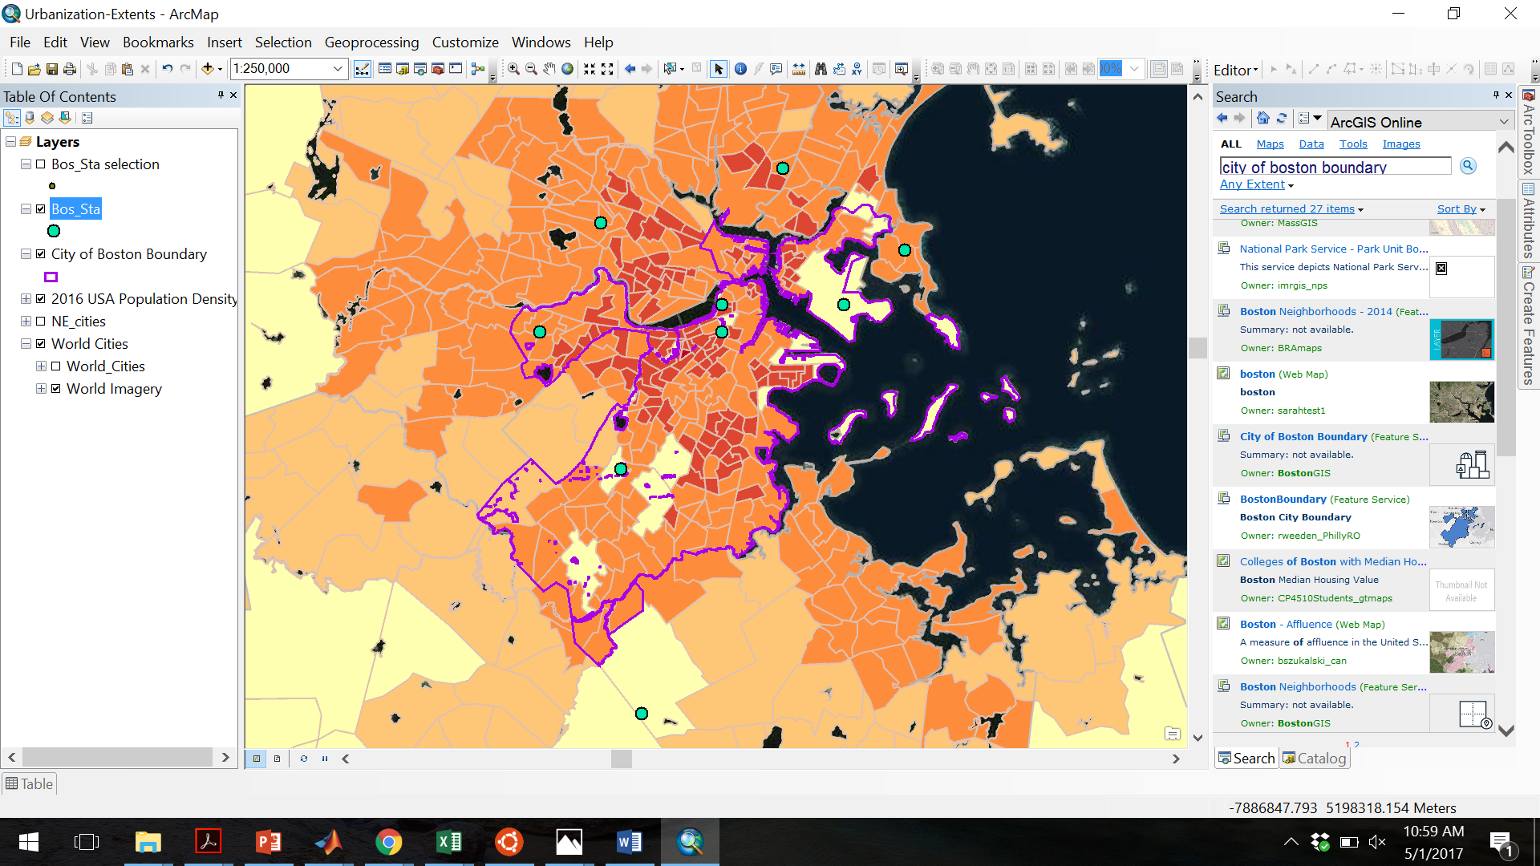

Figure S2. Same as Figure S1, but for the NYC area.

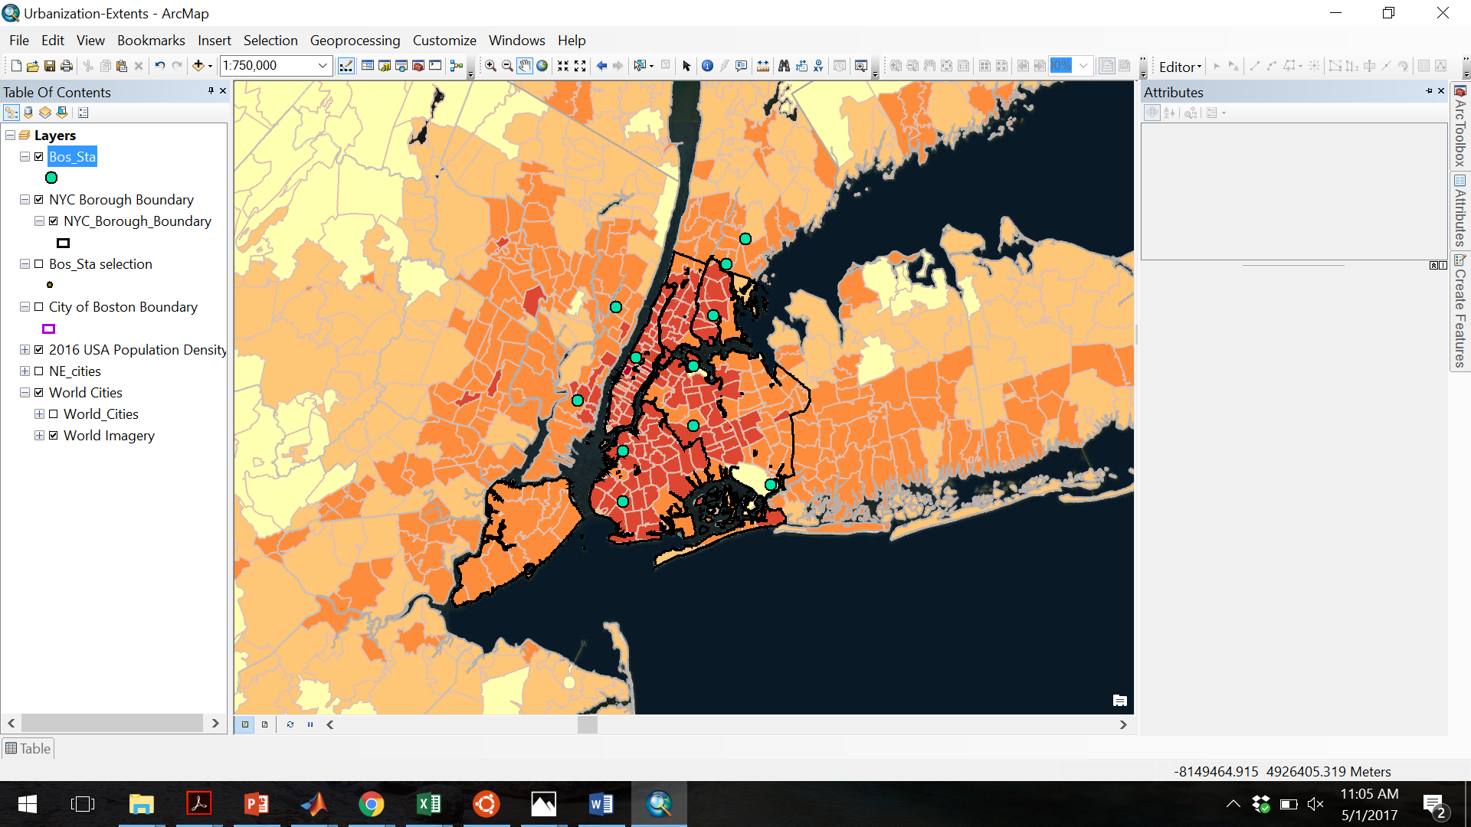

Figure S3. Land-based station vs. grid-average Metdata for selected stations with continuous data from 1997-2016 for the Boston area.

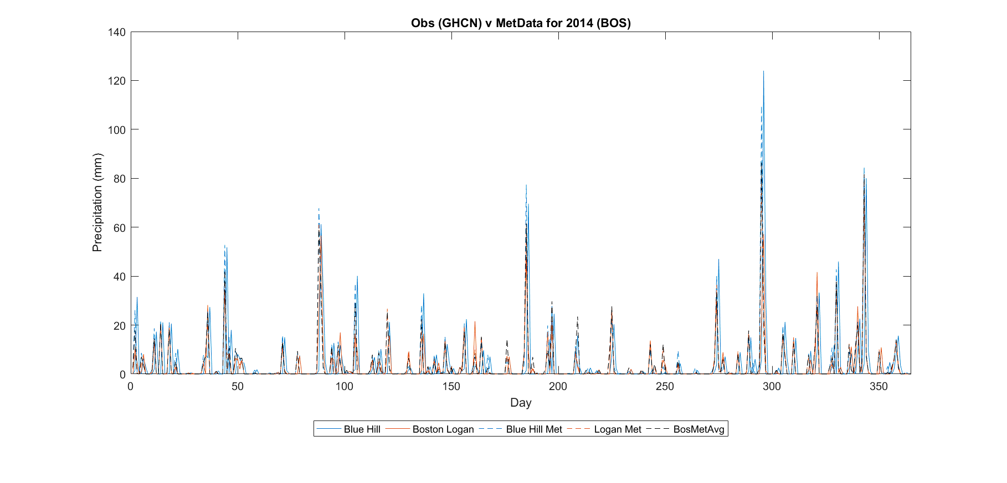

Figure S4. Same as figure S3, but for the NYC area.

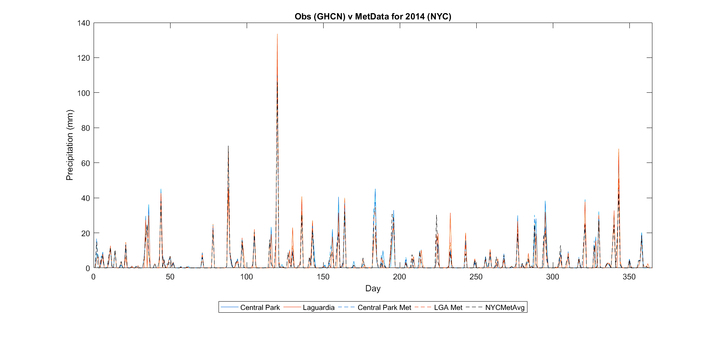

Figure S5.

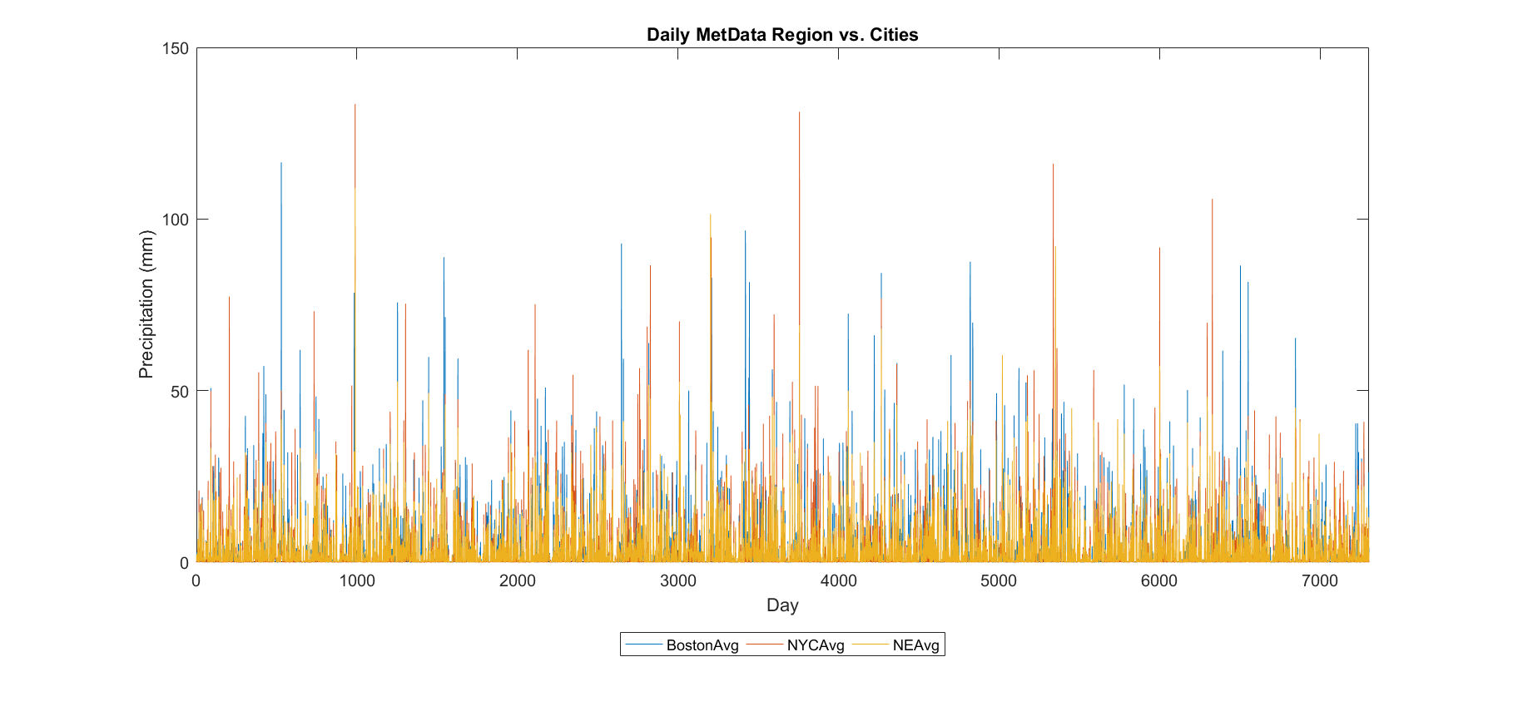

Table S1. Summary of selected GHCN stations, location, and data start and end dates.

|  |  |  |  |  |  |
| --- | --- | --- | --- | --- | --- |
| BOS_Station_Name | Station_ID | Lat | Lon | Start | End |
| BOSTON MA US (Logan) | GHCND:USW00014739 | 42.36 | -71.01 | 12/31/1935 | present |
| BOSTON 0.5 WSW MA US | GHCND:US1MASF0001 | 42.36 | -71.07 | 2/25/2009 | present |
| BRIGHTON 0.5 W MA US | GHCND:US1MASF0004 | 42.35 | -71.16 | 8/2/2011 | 12/25/2016 |
| JAMAICA PLAIN MA US | GHCND:USC00193890 | 42.3 | -71.12 | 8/14/1962 | present |
| WINCHESTER 0.7 SE MA US | GHCND:US1MAMD0007 | 42.45 | -71.14 | 6/20/2009 | present |
| WINTHROP 0.2 N MA US | GHCND:US1MASF0002 | 42.38 | -70.98 | 12/2/2009 | present |
| BLUE HILL MA US | GHCND:USC00190736 | 42.21 | -71.11 | 12/31/1892 | present |
| CHELSEA 0.8 N MA US | GHCND:US1MASF0010 | 42.41 | -71.04 | 6/20/2015 | present |
| CAMBRIDGE 0.9 NNW MA US | GHCND:US1MAMD0011 | 42.39 | -71.13 | 2/23/2010 | present |
|  |  |  |  |  |  |
| NYC_Station_Name | Station_ID | Lat | Lon | Start | End |
| Middle Village | GHCND:US1NYQN0002 | 40.71 | -73.88 | 2/1/2011 | present |
| Palisades Park | GHCND:US1NJBG0018 | 40.85 | -74 | 2/6/2008 | present |
| Upper Brooklyn | GHCND:US1NYKN0025 | 40.68 | -73.99 | 11/28/2013 | present |
| Central Park | GHCND:USW00094728 | 40.79 | -73.97 | 12/31/1868 | present |
| LGA | GHCND:USW00014732 | 40.78 | -73.88 | 10/6/1939 | present |
| JFK | GHCND:USW00094789 | 40.64 | -73.76 | 7/16/1948 | present |
| LowBrook | GHCND: US1NYKN0003 | 40.62 | -73.99 | 11/17/2008 | 5/30/2009 |
| Jersey City | GHCND:USC00284339 | 40.74 | -74.06 | 11/30/1905 | 5/30/1997 |
| Mt Vernon | GHCND:USC00305618 | 40.9 | -73.83 | 11/23/1914 | 12/30/1941 |
| Bronx | GHCND:USC00300961 | 40.84 | -73.85 | 10/31/1894 | 2/2/2014 |
| Eastchester | GHCND:USC00302291 | 40.93 | -73.8 | 6/12/1944 | 11/29/1958 |

Table S2. Parameters set in the RCM3 model run.

|  |  |  |
| --- | --- | --- |
| iproj | LAMCON | Map projection |
| iy | 74 | # grid points in y direction |
| jx | 85 | # grid points in x direction |
| ds | 60.0 | Grid point separation (km) |
| clat | 42 | Central latitude of domain (deg) |
| clon | -73 | Central longitude of domain (deg) |
| ntypec | 10 | Resolution of the global terrain and land-use data |
| IDATE1 | 2005100700 | Simulation start date |
| IDATE2 | 2005101200 | Simulation end date |
| SSTTYP | OI_WK | SST dataset |
| DATTYP | NNRP2 | Global analysis dataset |